Working with Excel Files in R Programming
Last Updated : 12 Jan, 2022

Excel files are of extension .xls, .xlsx and .csv(comma-separated values). To start working with excel files in R Programming Language, we need to first import excel files in RStudio or any other R supporting IDE(Integrated development environment).
Reading Excel Files in R Programming Language
First, install readxl package in R, under /Tools, to load excel files. Various methods including their subparts are demonstrated further.
The downloaded binary packages are in
C:\Users\bh\AppData\Local\Temp\Rtmpy8IEiC\downloaded_packages

https://www.appsilon.com/post/r-and-excel

indlæse data
library(readxl)
excel_example <- readxl_example("datasets.xlsx")
# "C:/Users/bh/AppData/Local/R/win-library/4.3/readxl/extdata/datasets.xlsx"

excel_sheets(excel_example)
[1] "iris" "mtcars" "chickwts" "quakes" # sheets i arket
As mentioned before, each of the four datasets is stored on an individual sheet. You can read a specific sheet by specifying the sheet parameter:
read_excel(excel_example, sheet = "mtcars")
# A tibble: 32 × 11, 32 rows,11 kolonner
mpg cyl disp hp drat wt qsec vs am gear carb
<dbl> <dbl> <dbl> <dbl> <dbl> <dbl> <dbl> <dbl> <dbl> <dbl> <dbl>
1 21 6 160 110 3.9 2.62 16.5 0 1 4 4

Udvælge range i sheet
read_excel(excel_example, sheet = "mtcars", range = "B1:E5")
A tibble: 4 × 4
cyl disp hp drat
<dbl> <dbl> <dbl> <dbl>
1 6 160 110 3.9
2 6 160 110 3.9
3 4 108 93 3.85
4 6 258 110 3.08

read_excel(excel_example, range = "mtcars!B1:G6")

read_excel(sheet) returns DataFrame, tableFrame:
tabel<-read_excel(excel_example, sheet = "mtcars") #det er en DataFrame!
tabel
class(tabel)
[1] "tbl_df" "tbl" "data.frame"
a<-5
class(a)
[1] "numeric"
iris<-read_excel(excel_example, sheet = "iris")

names(): to see the variable (column) names i indlæste DataFrame

head(Data1) # udskriver første 6 rows
install.packages("tidyversel")

# Working with Excel Files
# Installing required package
install.packages("readxl")

# Loading the package
library(readxl)

# Importing excel file
Data1 < - read_excel("Sample_data1.xlsx")
Data2 < - read_excel("Sample_data2.xlsx")

library(here)
lobsters <- read_xlsx(here("data/lobsters.xlsx"), skip=4) #skiber 4 rækker, here søger i /data undermappen for wkd

# Printing the data
head(Data1) # udskriver første 6 rows

head(Data2)
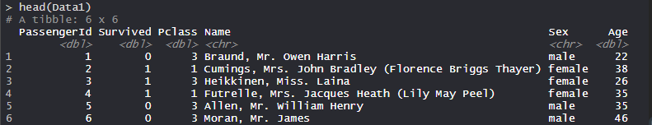
The excel files are loaded into variables Data_1 and Data_2 as a dataframes and then variable Data_1 and Data_2 is called that prints the dataset.

Modifying data/Files
The Sample_data1.xlsx file and Sample_file2.xlsx are modified.
- R
# Modifying the files
Data1$Pclass <- 0

Data2$Embarked <- "S"

# Printing the data
head(Data1)
head(Data2)
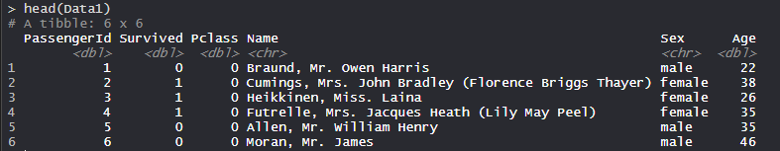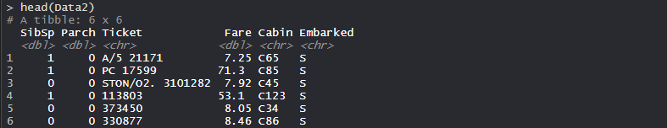
The value of the P-class attribute or variable of Data1 data is modified to 0. The value of Embarked attribute or variable of Data2 is modified to S.
Deleting Content from files
The variable or attribute is deleted from Data1 and Data2 datasets containing Sample_data1.xlsx and Sample_data2.xlsx files.
>

- R
# Deleting from files,

Kolonner nummeres 1,2,..

Data1 <- Data1[-2] #sletter kolonne 2 i Data1

Data2 <- Data2[-3]

# Printing the data
Data1
Data2
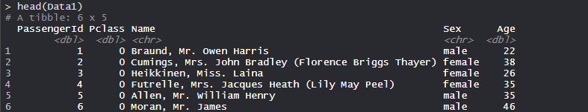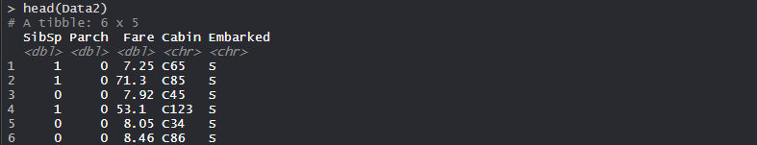
The – sign is used to delete columns or attributes from the dataset. Column 2 is deleted from the Data1 dataset and Column 3 is deleted from the Data2 dataset.
Merging Files
The two excel datasets Data1 and Data2 are merged using merge() function which is in base package and comes pre-installed in R.
- R
# Merging Files
Data3 <- merge(Data1, Data2, all.x = TRUE, all.y = TRUE)
# med same antal rækker, lægges kolonnerne i Data2 ind i Data1-sættet vist

# Displaying the data
head(Data3)
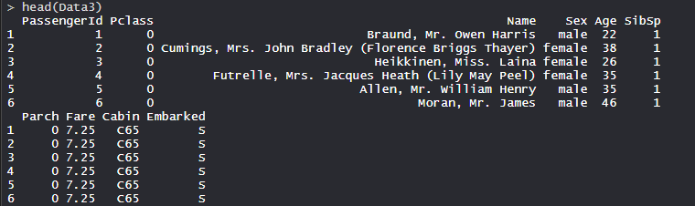
Data1 and Data2 are merged with each other and the resultant file is stored in the Data3 variable.

Creating new columns
New columns or features can be easily created in Data1 and Data2 datasets.
- R
# Creating feature in Data1 dataset
Data1$Num < - 0

# Creating feature in Data2 dataset
Data2$Code < - "Mission"

# Printing the data
head(Data1)
head(Data2)
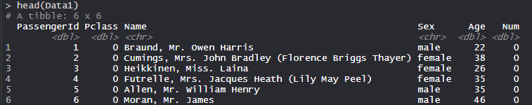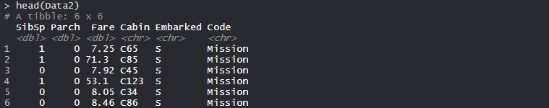
Num is a new feature that is created with 0 default value in Data1 dataset. Code is a new feature that is created with the mission as a default string in Data2 dataset.
#create data frame
df <- data.frame(team=c('A', 'B', 'C', 'D', 'E'),
points=c(99, 90, 86, 88, 95),
assists=c(33, 28, 31, 39, 34),
rebounds=c(30, 28, 24, 24, 28))

#view data frame
df
team points assists rebounds
1 A 99 33 30
2 B 90 28 28
3 C 86 31 24
4 D 88 39 24
5 E 95 34 28
Step 3: Use write.xlsx to Export Data Frame to Excel File

# write to working directory med openxlsx-library
Introduction (r-project.org)
library(openxlsx)
write.xlsx(df, 'my_data.xlsx')

df<-reawd.xlsx("C:\\Users\\bh\\Downloads\\Qaqortoq Matematik GUX screening (Responses).xlsx")

## write a list of data.frames to individual worksheets using list names as worksheet names

l <- list(DF1 = df, DF2= df)
write.xlsx(l, file = "writeXLSX2.xlsx") #skrives i filen, i to sheets/faner, DF1 og DF2

write.xlsx(l, file = "writeXLSXTable2.xlsx", asTable = TRUE) laver table, hvor der kan sorteres på hvert felt
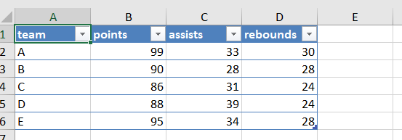

write.xlsx also accepts styling parameters
The simplest way is to set default options and set column class
options(openxlsx.borderColour = "#FF0000")
options(openxlsx.borderStyle = "thick")
options(openxlsx.dateFormat = "mm/dd/yyyy")
options(openxlsx.datetimeFormat = "yyyy-mm-dd hh:mm:ss")
options(openxlsx.numFmt = NULL) ## For default style rounding of numeric columns

df <- data.frame(Date = Sys.Date() - 0:19, LogicalT = TRUE, Time = Sys.time() - 0:19 *
60 * 60, Cash = paste("$", 1:20), Cash2 = 31:50, hLink = "https://CRAN.R-project.org/",
Percentage = seq(0, 1, length.out = 20), TinyNumbers = runif(20)/1e+09, stringsAsFactors = FALSE)

1:20 sekvens 1 itl 20; Date = Sys.Date() - 0:19, fratrækker 0,1,..19
df
Date LogicalT Time Cash Cash2
1 2024-08-13 TRUE 2024-08-13 16:10:05 $ 1 31
2 2024-08-12 TRUE 2024-08-13 15:10:05 $ 2 32
3 2024-08-11 TRUE 2024-08-13 14:10:05 $ 3 33
4 2024-08-10 TRUE 2024-08-13 13:10:05 $ 4 34
5 2024-08-09 TRUE 2024-08-13 12:10:05 $ 5 35
hLink Percentage TinyNumbers
1 https://CRAN.R-project.org/ 0.00000000 8.740417e-10
2 https://CRAN.R-project.org/ 0.05263158 1.623834e-10
3 https://CRAN.R-project.org/ 0.10526316 1.661710e-10
4 https://CRAN.R-project.org/ 0.15789474 3.467456e-10
5 https://CRAN.R-project.org/ 0.21052632 7.623542e-10

#defintion af typerne for kolonner, set column class
class(df$Cash) <- "currency"
class(df$Cash2) <- "accounting"
class(df$hLink) <- "hyperlink"
class(df$Percentage) <- "percentage"
class(df$TinyNumbers) <- "scientific"

write.xlsx(df, "writeXLSX3.xlsx")
write.xlsx(df, file = "writeXLSXTable3.xlsx", asTable = TRUE)
Workbook styles
define a style for column headers
hs <- createStyle(fontColour = "#ffffff", fgFill = "#4F80BD", halign = "center",
valign = "center", textDecoration = "Bold", border = "TopBottomLeftRight", textRotation = 45)

write.xlsx(df, file = "writeXLSX4.xlsx", borders = "rows", headerStyle = hs)
write.xlsx(df, file = "writeXLSX5.xlsx", borders = "columns", headerStyle = hs)
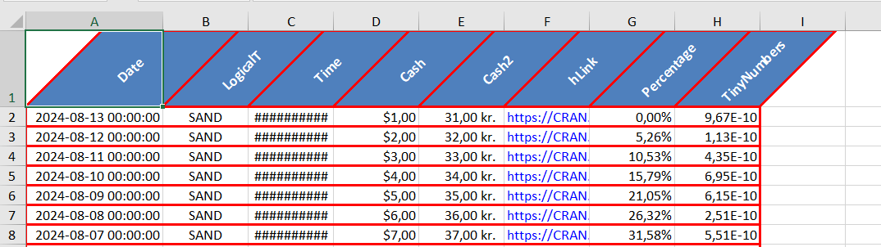
write.xlsx(iris, "writeXLSXTable4.xlsx", asTable = TRUE, headerStyle = createStyle(textRotation = 45))
When writing a list, the stylings will apply to all list elements
l <- list(IRIS = iris, colClasses = df) #def smart column types
write.xlsx(l, file = "writeXLSX6.xlsx", borders = "columns", headerStyle = hs)
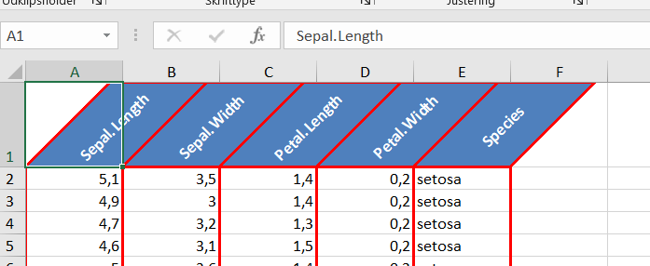
write.xlsx(l, file = "writeXLSXTable5.xlsx", asTable = TRUE, tableStyle = "TableStyleLight2")
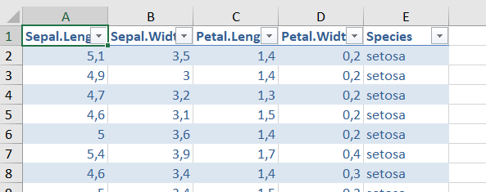

openXL("writeXLSX6.xlsx")
openXL("writeXLSXTable5.xlsx")
write.xlsx returns the workbook object for further editing
wb <- write.xlsx(iris, "writeXLSX6.xlsx")
setColWidths(wb, sheet = 1, cols = 1:5, widths = 20)
saveWorkbook(wb, "writeXLSX6.xlsx", overwrite = TRUE)
# cannot create file 'writeXLSX6.xlsx', reason 'Permission denied'n hvis arket er åbent I Excel

Workbook creation walk-through-example
create workbook and set default border Colour and style
wb <- createWorkbook()
options(openxlsx.borderColour = "#4F80BD")
options(openxlsx.borderStyle = "thin")
modifyBaseFont(wb, fontSize = 10, fontName = "Arial Narrow")
Add Sheets, to sheets gemmes I samme Excelfil, basics.xlsx, til sidst
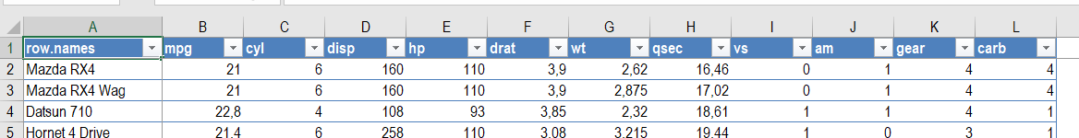
addWorksheet(wb, sheetName = "Motor Trend Car Road Tests", gridLines = FALSE) #simple her gemes kun data
addWorksheet(wb, sheetName = "Iris", gridLines = FALSE)
write data to sheet 1
freezePane(wb, sheet = 1, firstRow = TRUE, firstCol = TRUE) ## freeze first row and column
writeDataTable(wb, sheet = 1, x = mtcars, colNames = TRUE, rowNames = TRUE, tableStyle = "TableStyleLight9")
setColWidths(wb, sheet = 1, cols = "A", widths = 18)

write data to sheet 2
#iris data.frame is added as excel table on sheet 2. # data udskrives fra K2:
writeDataTable(wb, sheet = 2, iris, startCol = "K", startRow = 2)

Excel pivotable-Output
The same styling/formatting used for the HTML output is also used when outputting to Excel - greatly reducing the amount of script that needs to be written to create Excel output.
library(pivottabler)
pt <- PivotTable$new()
pt$addData(bhmtrains) # bhmtrains is a data frame with columns TrainCategory, TOC, etc.
pt$addColumnDataGroups("TrainCategory") # e.g. Express Passenger
pt$addRowDataGroups("TOC") # TOC = Train Operating Company e.g. Arriva Trains Wales
pt$addRowDataGroups("PowerType") # D/EMU = Diesel/Electric Multiple Unit, HST=High Speed Train
pt$defineCalculation(calculationName="TotalTrains", summariseExpression="n()")
pt$evaluatePivot()

library(openxlsx)
wb <- createWorkbook(creator = Sys.getenv("USERNAME"))
addWorksheet(wb, "Data")
pt$writeToExcelWorksheet(wb=wb, wsName="Data", topRowNumber=2, leftMostColumnNumber=2, applyStyles=TRUE)
# upper left (2,2)
saveWorkbook(wb, file="./data/pivottabel.xlsx", overwrite = TRUE) #, asTable = FALSE)
# man skal ikke lave table, for der mål ikke sorteres inde i Excel, så fucker pivot-tabellen op
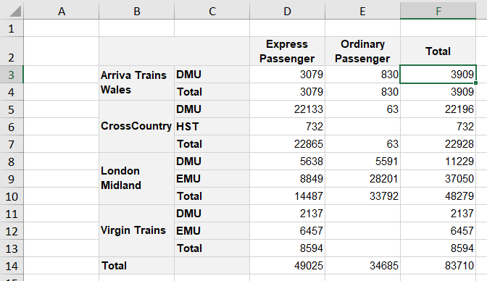

plot data

require(ggplot2)
qplot(data = iris, x = Sepal.Length, y = Sepal.Width, colour = Species) # laver/viser graf I viewer, plot gemmes i sheet2
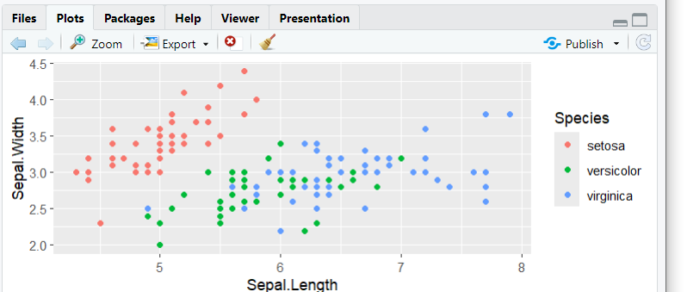
De blå x’er, = Sepal.Length for virginca, har større spredning og middel(6.5) end to andre, passer med mean og sd

## insert plot at cell B16 in worksheet, øverste venstre hjørne,
insertPlot(wb, 2, xy = c("B", 16))

Gruppering og count, mean indenfor grupperinger

df_by_A_B <-df %>% group_by(A,B ) #gruppering efter A og B -størrelser, man ser ikke gruppering ved udprint!
df_by_A_B %>% summarise( n(),mean(C) ) viser antal I hver gruppe og mean af C-værdi

library(dplyr)
bhmtrains %>% count(TOC,TrainCategory) #virker, %>% er piping videre frem

Finder middel og spredningen over kolonne-data:
means <- aggregate(x = poopdeck[, ], by = list(poopdeck$type, poopdeck$cleaner), FUN = mean)

means <- aggregate(x = iris[, -5], by = list(iris$Species), FUN = mean) #laver aggregereing efer gruppene i iris$Species I de 4 kolonner,
iris[, -5] #udvælger alle kolonner undtagen nr 5

means -dataframe
Group.1 Sepal.Length Sepal.Width Petal.Length Petal.Width
1 setosa 5.006 3.428 1.462 0.246
2 versicolor 5.936 2.770 4.260 1.326
3 virginica 6.588 2.974 5.552 2.026

vars <- aggregate(x = iris[, -5], by = list(iris$Species), FUN = var) #varians
sd <- aggregate(x = iris[, -5], by = list(iris$Species), FUN = sd) #spredning
sd
Group.1 Sepal.Length Sepal.Width Petal.Length Petal.Width
1 setosa 0.3524897 0.3790644 0.1736640 0.1053856
2 versicolor 0.5161711 0.3137983 0.4699110 0.1977527
3 virginica 0.6358796 0.3224966 0.5518947 0.2746501
De blå x’er, = Sepal.Length for virginca, har større spredning og middel(6.5) end to andre, som det ses i grafen ovenfor!

#write group means-dataset in excelark
headSty <- createStyle(fgFill = "#DCE6F1", halign = "center", border = "TopBottomLeftRight") #lyseblå, kolonne-felt-tekster horizontal alignment
writeData(wb, 2, x = "Iris dataset group means", startCol = 2, startRow = 2) # i sheet 2
writeData(wb, 2, x = means, startCol = "B", startRow = 3, borders = "rows", headerStyle = headSty)
#write group variances
writeData(wb, 2, x = "Iris dataset group variances", startCol = 2, startRow = 9)
writeData(wb, 2, x = vars, startCol = "B", startRow = 10, borders = "columns", headerStyle = headSty)

setColWidths(wb, 2, cols = 2:6, widths = 12) ## width is recycled for each col
setColWidths(wb, 2, cols = 11:15, widths = 15) #tabellen med hele data-tabellen
#add style mean & variance table headers
s1 <- createStyle(fontSize = 14, textDecoration = c("bold", "italic"))
addStyle(wb, 2, style = s1, rows = c(2, 9), cols = c(2, 2))
#save workbook
saveWorkbook(wb, "basics.xlsx", overwrite = TRUE) ## save to working directory
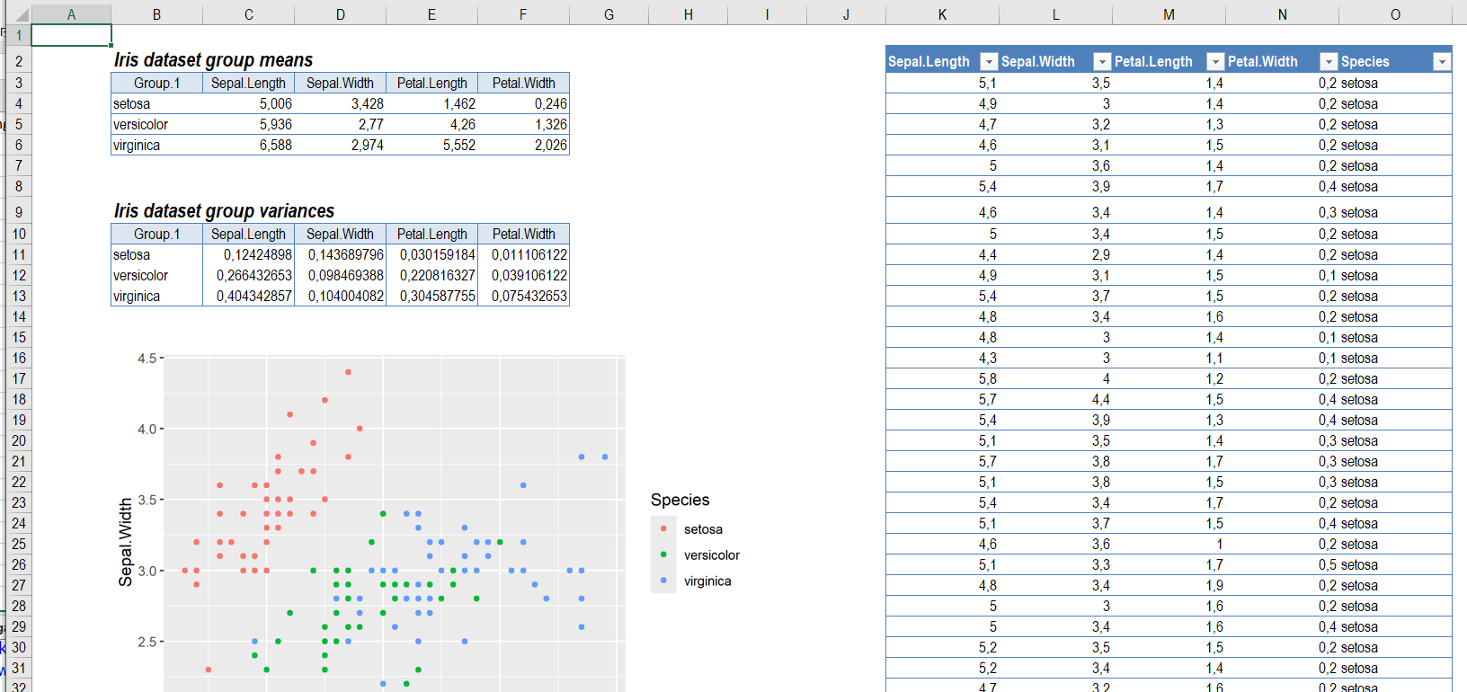

Gallery
## inspired by xtable gallery
#https://CRAN.R-project.org/package=xtable/vignettes/xtableGallery.pdf

## Create a new workbook
wb <- createWorkbook()
data(tli, package = "xtable") #tli er indbygget dataset i xtable
tli
grade sex disadvg ethnicty tlimth
1 6 M YES HISPANIC 43
2 7 M NO BLACK 88
3 5 F YES HISPANIC 34…

## data.frame
test.n <- "data.frame" #bliver sheetname
my.df <- tli[1:10, ] #row 1-10
addWorksheet(wb = wb, sheetName = test.n)
writeData(wb = wb, sheet = test.n, x = my.df, borders = "n")

## matrix
test.n <- "matrix"
design.matrix <- model.matrix(~ sex * grade, data = my.df) #modelfit (sex,grade) ?
addWorksheet(wb = wb, sheetName = test.n)
writeData(wb = wb, sheet = test.n, x = design.matrix)
> design.matrix
(Intercept) sexM grade sexM:grade
1 1 1 6 6
2 1 1 7 7
3 1 0 5 0
qplot(data = my.df, x = sex, y = grade) # laver/viser graf I viewer, plot gemmes i sheet2

## aov
test.n <- "aov"
fm1 <- aov(tlimth ~ sex + ethnicty + grade + disadvg, data = tli)
#der laves model over tlimth som fct af øvrige størrelser
addWorksheet(wb = wb, sheetName = test.n)
writeData(wb = wb, sheet = test.n, x = fm1)

> fm1
Call:
aov(formula = tlimth ~ sex + ethnicty + grade + disadvg, data = tli)

Terms:
sex ethnicty grade disadvg Residuals
Sum of Squares 75.373 2572.149 36.307 59.303 18682.867
Deg. of Freedom 1 3 1 1 93
4 forskellige ethnicty -værdier
Residual standard error: 14.1736
Estimated effects may be unbalanced

## lm, vis en lineær model?
test.n <- "lm"
fm2 <- lm(tlimth ~ sex*ethnicty, data = tli)
addWorksheet(wb = wb, sheetName = test.n)
writeData(wb = wb, sheet = test.n, x = fm2)

> fm2

Call:
lm(formula = tlimth ~ sex * ethnicty, data = tli)

Coefficients:
(Intercept) sexM ethnictyHISPANIC
73.636 -1.636 -9.761
ethnictyOTHER ethnictyWHITE sexM:ethnictyHISPANIC
15.864 4.797 10.678
sexM:ethnictyOTHER sexM:ethnictyWHITE
NA 5.123

## anova 1
test.n <- "anova"
my.anova <- anova(fm2)
addWorksheet(wb = wb, sheetName = test.n)
writeData(wb = wb, sheet = test.n, x = my.anova)

## anova 2
test.n <- "anova2"
fm2b <- lm(tlimth ~ ethnicty, data = tli)
my.anova2 <- anova(fm2b, fm2)
addWorksheet(wb = wb, sheetName = test.n)
writeData(wb = wb, sheet = test.n, x = my.anova2)

## glm
test.n <- "glm"
fm3 <- glm(disadvg ~ ethnicty*grade, data = tli, family = binomial())
addWorksheet(wb = wb, sheetName = test.n)
writeData(wb = wb, sheet = test.n, x = fm3)

## prcomp
test.n <- "prcomp"
pr1 <- prcomp(USArrests)
addWorksheet(wb = wb, sheetName = test.n)
writeData(wb = wb, sheet = test.n, x = pr1)

## summary.prcomp
test.n <- "summary.prcomp"
addWorksheet(wb = wb, sheetName = test.n)
writeData(wb = wb, sheet = test.n, x = summary(pr1))

## simple table
test.n <- "table"
data(airquality)
airquality$OzoneG80 <- factor(airquality$Ozone > 80,
levels = c(FALSE, TRUE),
labels = c("Oz <= 80", "Oz > 80"))
airquality$Month <- factor(airquality$Month,
levels = 5:9,
labels = month.abb[5:9])
my.table <- with(airquality, table(OzoneG80,Month) )
addWorksheet(wb = wb, sheetName = test.n)
writeData(wb = wb, sheet = test.n, x = my.table)

## survdiff 1
library(survival)
test.n <- "survdiff1"
addWorksheet(wb = wb, sheetName = test.n)
x <- survdiff(Surv(futime, fustat) ~ rx, data = ovarian)
writeData(wb = wb, sheet = test.n, x = x)

## survdiff 2
test.n <- "survdiff2"
addWorksheet(wb = wb, sheetName = test.n)
expect <- survexp(futime ~ ratetable(age=(accept.dt - birth.dt),
sex=1,year=accept.dt,race="white"), jasa, cohort=FALSE,
ratetable=survexp.usr)
x <- survdiff(Surv(jasa$futime, jasa$fustat) ~ offset(expect))
writeData(wb = wb, sheet = test.n, x = x)

## coxph 1
test.n <- "coxph1"
addWorksheet(wb = wb, sheetName = test.n)
bladder$rx <- factor(bladder$rx, labels = c("Pla","Thi"))
x <- coxph(Surv(stop,event) ~ rx, data = bladder)
writeData(wb = wb, sheet = test.n, x = x)

## coxph 2
test.n <- "coxph2"
addWorksheet(wb = wb, sheetName = test.n)
x <- coxph(Surv(stop,event) ~ rx + cluster(id), data = bladder)
writeData(wb = wb, sheet = test.n, x = x)

## cox.zph
test.n <- "cox.zph"
addWorksheet(wb = wb, sheetName = test.n)
x <- cox.zph(coxph(Surv(futime, fustat) ~ age + ecog.ps, data=ovarian))
writeData(wb = wb, sheet = test.n, x = x)

## summary.coxph 1
test.n <- "summary.coxph1"
addWorksheet(wb = wb, sheetName = test.n)
x <- summary(coxph(Surv(stop,event) ~ rx, data = bladder))
writeData(wb = wb, sheet = test.n, x = x)

## summary.coxph 2
test.n <- "summary.coxph2"
addWorksheet(wb = wb, sheetName = test.n)
x <- summary(coxph(Surv(stop,event) ~ rx + cluster(id), data = bladder))
writeData(wb = wb, sheet = test.n, x = x)

## view without saving
openXL(wb)
Further Examples
Stock Price
require(ggplot2)

wb <- createWorkbook()

## read historical prices from yahoo finance
ticker <- "CBA.AX"
csv.url <- paste0("https://query1.finance.yahoo.com/v7/finance/download/", ticker,
"?period1=1597597610&period2=1629133610&interval=1d&events=history&includeAdjustedClose= True")
# 'URL using bad/illegal format or missing URL'

csv.url <- paste0("https://query1.finance.yahoo.com/v7/finance/download/", ticker,
"?period1=1597597610&period2=1629133610&interval=1d&events=history") # her kommer tal tilbage:
> prices <- read.csv(url(csv.url), as.is = TRUE) #254 rækker, (1629133610-1597597610)/(24*3600)= 365, altså 1år, ca 365- (105+#helligedage)
)
> prices
Date Open High Low Close Adj.Close Volume
1 2020-08-17 71.10 71.450 70.650 70.76 60.73630 3329741
2 2020-08-18 70.80 71.240 70.030 70.48 60.49597 4601033
interval=1day, perioder er vist unix timestamp

csv.url <- paste0("https://query1.finance.yahoo.com/v7/finance/download/", ticker,
"?period1=1597597610&period2=1629133610&interval=1d&events=history&includeAdj.Close = True") #fejl

Since the previous Yahoo Finance download URL is not working anymore, I are now left with something like this:
https://query1.finance.yahoo.com/v7/finance/download/AAPL?period1=1492524105&period2=1495116105&interval=1d&events=history&crumb=tO1hNZoUQeQ
Does anybody know how the period1 (and period2) translate into a date (and viceversa)

prices <- read.csv(url(csv.url), as.is = TRUE)
prices$Date <- as.Date(prices$Date)
close <- prices$Close
prices$logReturns = c(0, log(close[2:length(close)]/close[1:(length(close) - 1)]))
ser på talforholdene log(close_{i}/close_{i-1}), i=1,2,… ; close_{i}/close_{i-1er} kurs-return fra en dag til næste,>0 viser kursstiging
indeksværdierne i gennemløbes automatisk med sekvensen, første værdi sættes til 0
log(70.48/70.76)= -0.003964888 for log( dag₁/dag₀)
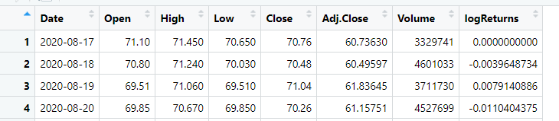
summary(prices$logReturns)
Min. 1st Qu. Median Mean 3rd Qu. Max.
-0.0558262 -0.0062074 0.0009335 0.0014605 0.0103141 0.0350047

## Create plot of price series and add to worksheet
ggplot(data = prices, aes(as.Date(Date), as.numeric(Close))) + geom_line(colour = "royalblue2") +
labs(x = "Date", y = "Price", title = ticker) + geom_area(fill = "royalblue1",
alpha = 0.3) + coord_cartesian(ylim = c(min(prices$Close) - 1.5, max(prices$Close) +
1.5))
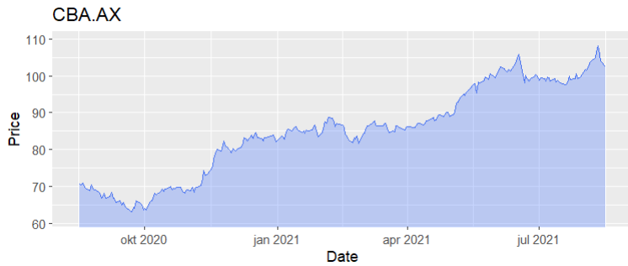

## Add worksheet and write plot to sheet
addWorksheet(wb, sheetName = "CBA")
insertPlot(wb, sheet = 1, xy = c("J", 3))

## Histogram of log returns
ggplot(data = prices, aes(x = logReturns)) + geom_histogram(binwidth = 0.0025) +
labs(title = "Histogram of log returns")
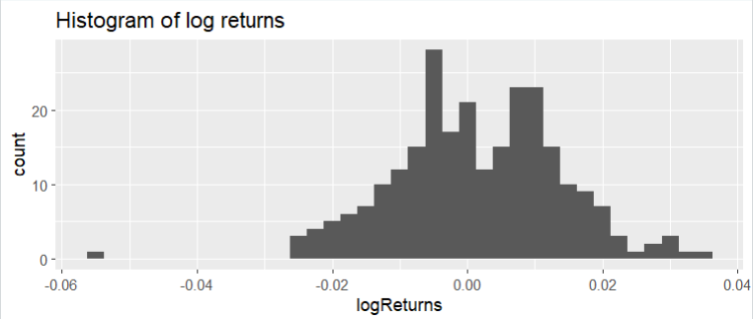optæller antal dage med forskellige log(returns)

## currency
class(prices$Close) <- "currency" ## styles as currency in workbook

## write historical data and histogram of returns
writeDataTable(wb, sheet = "CBA", x = prices)
insertPlot(wb, sheet = 1, startRow = 25, startCol = "J")

## Add conditional formatting to show where logReturn > 0.01 using default
## style
conditionalFormat(wb, sheet = 1, cols = 1:ncol(prices), rows = 2:(nrow(prices) +
1), rule = "$H2 > 0.01")

## style log return col as a percentage
logRetStyle <- createStyle(numFmt = "percentage")

addStyle(wb, 1, style = logRetStyle, rows = 2:(nrow(prices) + 1), cols = "H", gridExpand = TRUE)

setColWidths(wb, sheet = 1, cols = c("A", "F", "G", "H"), widths = 15)

## save workbook to working directory
saveWorkbook(wb, "stockPrice.xlsx", overwrite = TRUE)
openXL("stockPrice.xlsx") #åbner Excelarket med Excel
Image Compression using PCA
require(openxlsx)
require(jpeg)
require(ggplot2)

plotFn <- function(x, ...){
colvec <- grey(x)
colmat <- array(match(colvec, unique(colvec)), dim = dim(x)[1:2])
image(x = 0:(dim(colmat)[2]), y = 0:(dim(colmat)[1]), z = t(colmat[nrow(colmat):1, ]),
col = unique(colvec), xlab = "", ylab = "", axes = FALSE, asp = 1,
bty ="n", frame.plot=F, ann=FALSE)
}

## Create workbook and add a worksheet, hide gridlines
wb <- createWorkbook("Einstein")
addWorksheet(wb, "Original Image", gridLines = FALSE)

A <- readJPEG(system.file("extdata", "einstein.jpg", package = "openxlsx"))
height <- nrow(A); width <- ncol(A)

## write "Original Image" to cell B2
writeData(wb, 1, "Original Image", xy = c(2,2))

## write Object size to cell B3
writeData(wb, 1, sprintf("Image object size: %s bytes",
format(object.size(A+0)[[1]], big.mark=',')),
xy = c(2,3)) ## equivalent to startCol = 2, startRow = 3

## Plot image
par(mar=rep(0, 4), xpd = NA); plotFn(A)

## insert plot currently showing in plot window
insertPlot(wb, 1, width, height, units="px", startRow= 5, startCol = 2)

## SVD of covariance matrix
rMeans <- rowMeans(A)
rowMeans <- do.call("cbind", lapply(1:ncol(A), function(X) rMeans))
A <- A - rowMeans
E <- svd(A %*% t(A) / (ncol(A) - 1)) # SVD on covariance matrix of A
pve <- data.frame("Eigenvalues" = E$d,
"PVE" = E$d/sum(E$d),
"Cumulative PVE" = cumsum(E$d/sum(E$d)))

## write eigenvalues to worksheet
addWorksheet(wb, "Principal Component Analysis")
hs <- createStyle(fontColour = "#ffffff", fgFill = "#4F80BD",
halign = "CENTER", textDecoration = "Bold",
border = "TopBottomLeftRight", borderColour = "#4F81BD")

writeData(wb, 2, x="Proportions of variance explained by Eigenvector" ,startRow = 2)
mergeCells(wb, sheet=2, cols=1:4, rows=2)

setColWidths(wb, 2, cols = 1:3, widths = c(14, 12, 15))
writeData(wb, 2, x=pve, startRow = 3, startCol = 1, borders="rows", headerStyle=hs)

## Plots
pve <- cbind(pve, "Ind" = 1:nrow(pve))
ggplot(data = pve[1:20,], aes(x = Ind, y = 100*PVE)) +
geom_bar(stat="identity", position = "dodge") +
xlab("Principal Component Index") + ylab("Proportion of Variance Explained") +
geom_line(size = 1, col = "blue") + geom_point(size = 3, col = "blue")

## Write plot to worksheet 2
insertPlot(wb, 2, width = 5, height = 4, startCol = "E", startRow = 2)

## Plot of cumulative explained variance
ggplot(data = pve[1:50,], aes(x = Ind, y = 100*Cumulative.PVE)) +
geom_point(size=2.5) + geom_line(size=1) + xlab("Number of PCs") +
ylab("Cumulative Proportion of Variance Explained")
insertPlot(wb, 2, width = 5, height = 4, xy= c("M", 2))

## Reconstruct image using increasing number of PCs
nPCs <- c(5, 7, 12, 20, 50, 200)
startRow <- rep(c(2, 24), each = 3)
startCol <- rep(c("B", "H", "N"), 2)

## create a worksheet to save reconstructed images to
addWorksheet(wb, "Reconstructed Images", zoom = 90)

for(i in 1:length(nPCs)){

V <- E$v[, 1:nPCs[i]]
imgHat <- t(V) %*% A ## project img data on to PCs
imgSize <- object.size(V) + object.size(imgHat) + object.size(rMeans)

imgHat <- V %*% imgHat + rowMeans ## reconstruct from PCs and add back row means
imgHat <- round((imgHat - min(imgHat)) / (max(imgHat) - min(imgHat))*255) # scale
plotFn(imgHat/255)

## write strings to worksheet 3
writeData(wb, "Reconstructed Images",
sprintf("Number of principal components used: %s",
nPCs[[i]]), startCol[i], startRow[i])

writeData(wb, "Reconstructed Images",
sprintf("Sum of component object sizes: %s bytes",
format(as.numeric(imgSize), big.mark=',')), startCol[i], startRow[i]+1)

## write reconstruced image
insertPlot(wb, "Reconstructed Images", width, height, units="px",
xy = c(startCol[i], startRow[i]+3))

}

# hide grid lines
showGridLines(wb, sheet = 3, showGridLines = FALSE)

## Make text above images BOLD
boldStyle <- createStyle(textDecoration="BOLD")

## only want to apply style to specified cells (not all combinations of rows & cols)
addStyle(wb, "Reconstructed Images", style=boldStyle,
rows = c(startRow, startRow+1), cols = rep(startCol, 2),
gridExpand = FALSE)

## save workbook to working directory
saveWorkbook(wb, "Image dimensionality reduction.xlsx", overwrite = TRUE)

## remove example files for cran test
if (identical(Sys.getenv("NOT_CRAN", unset = "true"), "false")) {
file_list<-list.files(pattern="\\.xlsx",recursive = T)
file_list<-fl[!grepl("inst/extdata",file_list)&!grepl("man/",file_list)]

if(length(file_list)>0){
rm(file_list)
}
}

Bert is a free tool for connecting Excel with R
It's designed to run (user-defined) R functions in spreadsheets. The only thing you have to do is write the function - Bert handles everything else for you. But here's a catch: At this time, Bert is available only for Windows. We're running Windows 11 as an emulation on M1 Macbook (ARM) and experiencing unexpected crashes. These are likely due to the ARM architecture Bert didn't expect. Now, Bert isn't the only option you have. Similar solutions exist, such as RExcel, but we haven't managed to find a download link due to their website being down. Adding insult to injury, RExcel is also available for Windows only. To get started with Bert, head over to their download page and download the installed. It goes without saying, but you should have Excel and R installed already. Once you have both Excel and Bert console running, use the following code to populate cells in the range from A1 to C4 with a constant value:
range <- EXCEL$Application$get_Range("A1:C4")
range$put_Value(3.14)

Sample_data1.xlsx:

Sample_data2.xlsx:

Reading Files:
The two excel files Sample_data1.xlsx and Sample_data2.xlsx and read from the working directory.
R

D

dhruv5819
Follow
3
Previous Article
Working with XML Files in R Programming
Next Article
Working with JSON Files in R Programming
Similar Reads

Working with XML Files in R Programming
XML which stands for Extensible Markup Language is made up of markup tags, wherein each tag illustrates the information carried by the particular attribute in the XML file. We can work with the XML files using the XML package provided by R. The package has to be explicitly installed using the following command: install.packages("XML")Creating XML f
3 min read

Working with Binary Files in R Programming
In the computer science world, text files contain data that can easily be understood by humans. It includes letters, numbers, and other characters. On the other hand, binary files contain 1s and 0s that only computers can interpret. The information stored in a binary file can't be read by humans as the bytes in it translate to characters and symbol
5 min read

Working with JSON Files in R Programming
JSON stands for JavaScript Object Notation. These files contain the data in human readable format, i.e. as text. Like any other file, one can read as well as write into the JSON files. In order to work with JSON files in R, one needs to install the "rjson" package. The most common tasks done using JSON files under rjson packages are as follows: Ins
4 min read

Working with CSV files in R Programming
In this article, we will discuss how to work with CSV files in R Programming Language. R CSV Files R CSV Files are text files wherein the values of each row are separated by a delimiter, as in a comma or a tab. In this article, we will use the following sample CSV file. Getting and Setting the Working Directory with R CSV Files C/C++ Code # Get the
4 min read

Read CSV-files -> dataFrame
Reading a R CSV Files
The contents of a CSV file can be read as a data frame in R using the read.csv(…) function. The CSV file to be read should be either present in the current working directory or the directory should be set accordingly using the setwd(…) command in R. The CSV file can also be read from a URL using read.csv() function.
- R
csv_data <- read.csv(file = 'C:\\Users\\GFG19565\\Downloads\\sample.csv')
"data/test3.xlsx"
csv_data <- read.csv(file = 'data/Lobster_Abundance_All_Years_20240411.csv')
Lobster_Abundance_All_Years_20240411
writexl::write_xlsx(list(my_sheet_name2 = df),
+ "data/test3.xlsx")
class(csv_data)
[1] "data.frame"

Lobster_Abundance_All_Years_20240411.csv
print(csv_data)

# print number of columns
print (ncol(csv_data))

# print number of rows
print(nrow(csv_data))

1. Use write.csv from base R, for small files
If your data frame is reasonably small, you can just use the write.csv function from base R to export it to a CSV file.
When using this method, be sure to specify row.names=FALSE if you don’t want R to export the row names to the CSV file.
write.csv(df, "C:\\Users\\Bob\\Desktop\\data.csv", row.names=FALSE) eller write.csv(df, "data/data.csv", row.names=FALSE) hvor fil gemmes i /data i getwd()

2. Use write_csv from reader package
An even faster way to export a data frame to a CSV file is with the write_csv function from the reader package. This is about 2x faster than write.csv and it never writes the row names from the data frame to a CSV file.
library(readr)
write_csv(df, "C:\\Users\\Bob\\Desktop\\data.csv")

3. Use fwrite from data.table package
Yet a faster way (and a recommended method for large datasets) to export a data frame to a CSV file is with the fwrite function from the data.table package. This function is about 2x faster than the write_csv method.
library(data.table)
fwrite(df, "C:\\Users\\Bob\\Desktop\\data.csv")

Note that in each example we used double backslashes (\\) in the file path to avoid the following common error:
Error: '\U' used without hex digits in character string starting ""C:\U"
The Output
Each of the three methods above produce an identical CSV file. If we open this file with Excel, here’s what it looks like, ikke hos mig, men indenfra Excel kan data hentes under /Data/Extern fil
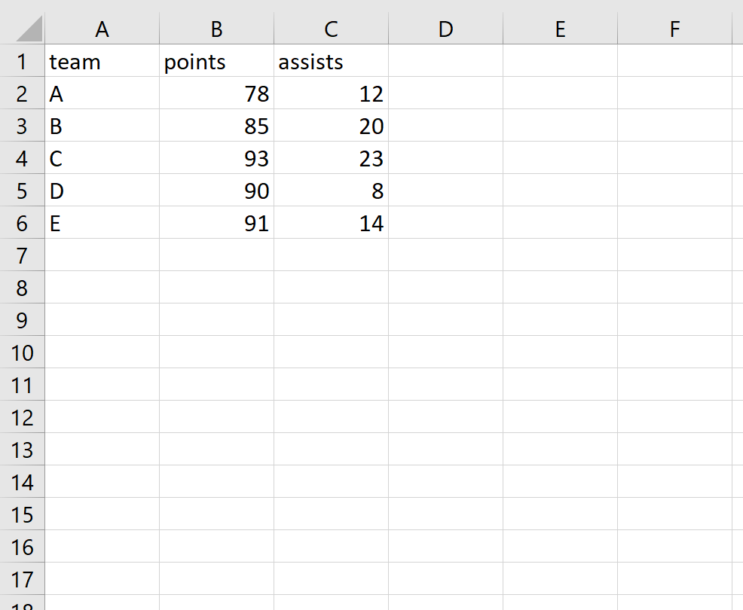
And if we open the CSV file with a text reader like Notepad, here’s what it looks like:
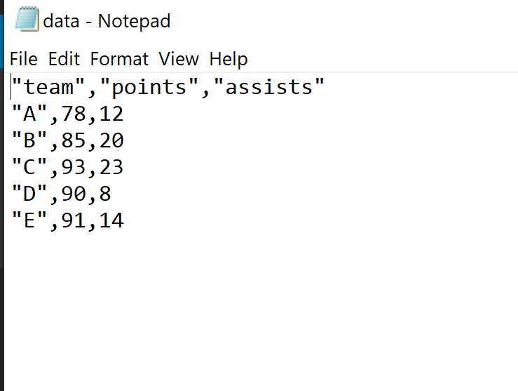

How to Write Multiple Excel Files From Column Values - R programming
A data frame is a cell-based structure comprising rows and columns belonging to the same or different data types. Each cell in the data frame is associated with a unique value, either a definite value or a missing value, indicated by NA. The data frame structure is in complete accordance with the Excel sheet structure. Therefore, the data frame val
6 min read

View More Articles
Article Tags :
- R Language
- R-FileHandling

